INTRODUTION
OVERVIEW
- To create a social media for our institution
- Purpose
To reach the students with tha invitation
PURPOSE

PROBLEM DEFINITION & DESIGN THINKING
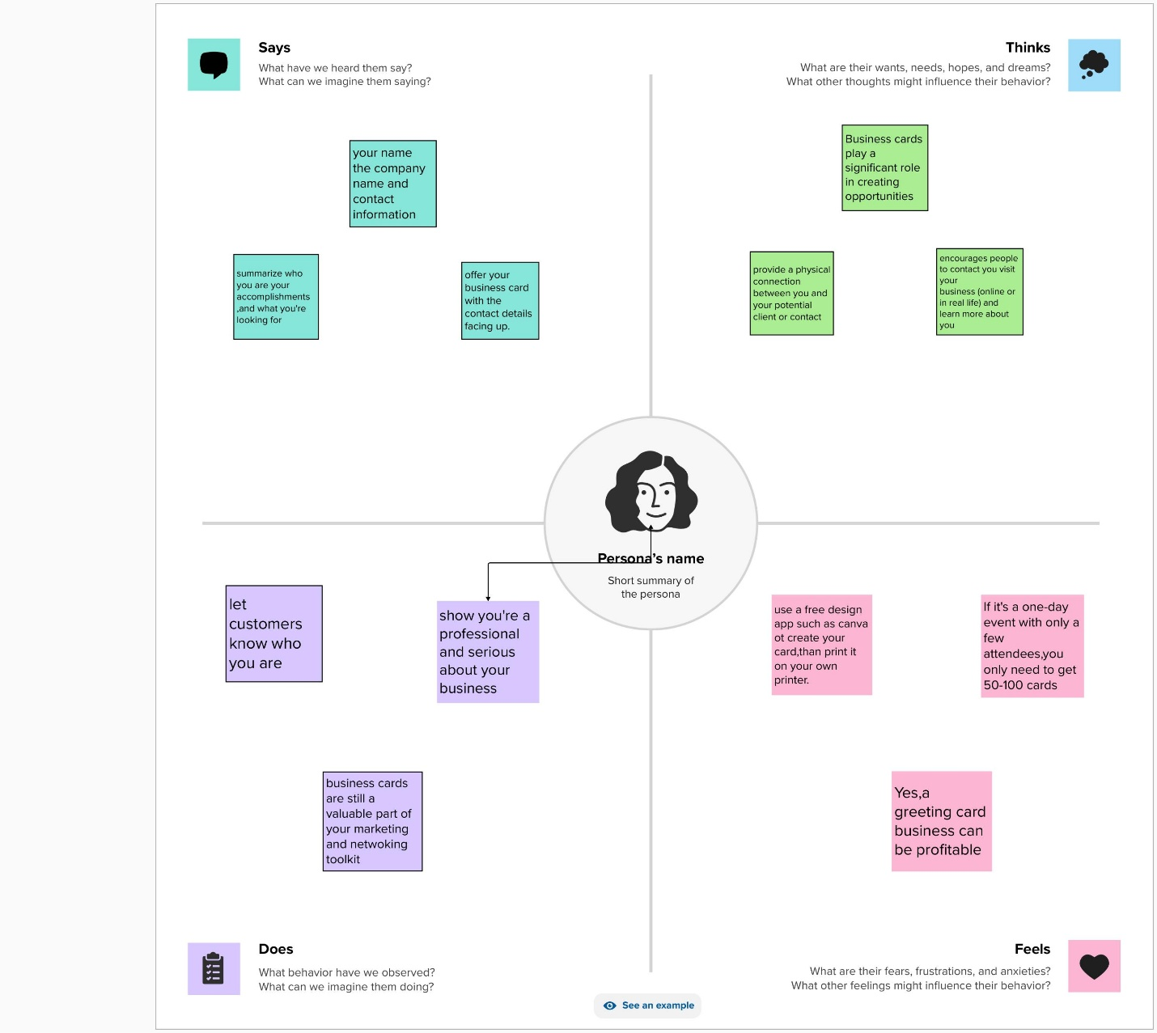
EMPATHY MAP:

BRAIN STROM :
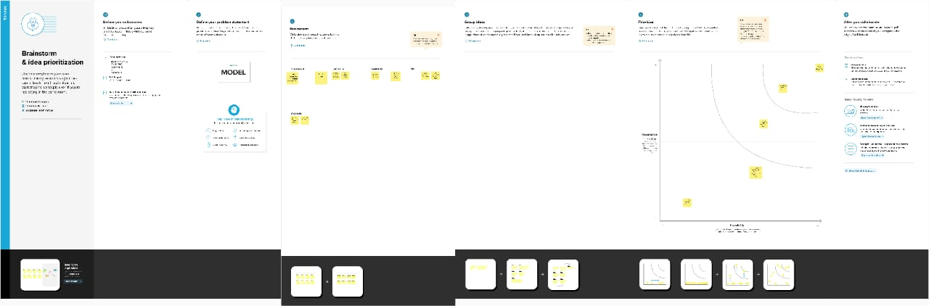

RESULT
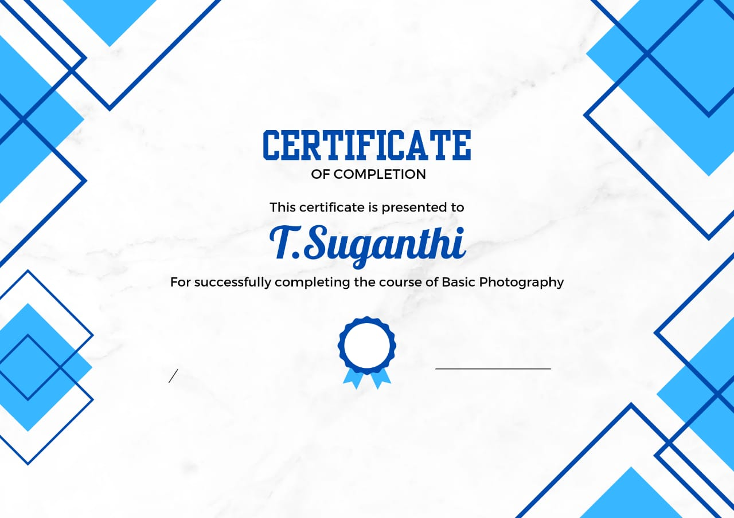

ADVANTAGES & DISADVANTAGE
- Our certificate can reach the people easily this can improve our certificate
- Iliterate may not understand

APPLICATION:
It have develop my certificate

CONCLUSION:
With help of canva app we have design our project successful

